SIMX • WHITE PAPER • ENGLISH MASTER

SIMX WHITE PAPER
Membership-Rights Investment Token & Membership Pass
An investment-token framework for participation in Thailand's premium club-membership network

Version 1.0 | 20 September 2026
Prepared by Digital Tourism Alliance Co., Ltd. (DTA)
DOCUMENT STATUS
This White Paper describes the SIMX project as currently designed and is published for review by a Thai ICO Portal, the Thai SEC and qualified legal advisers. It is not a prospectus, a token sale offer, a Thai SEC approval, a legal opinion, or an assurance of exchange listing, liquidity, price, distribution or membership approval.

Document Control
Field | Current position
Document | SIMX White Paper
Version / date | 1.0 / 20 September 2026
Master language | English only
Status | Published. Parameters marked as decision gates are determined under the process stated in each chapter.
Token structure | Two instruments on two sides of one transaction. SIMX: an investment token issued in Thailand by a DTA special purpose vehicle, representing participation in a portfolio of golf and hotel club memberships held in trust and a variable share of the usage income they generate. the Membership Pass: a utility token issued outside Thailand, carrying the right to use those memberships at published programme levels.
Payment position | Neither SIMX nor the Membership Pass is a means of payment
Regulatory position | SIMX is offered as an Investment Token through an SEC-approved ICO Portal. The Membership Pass is a ready-to-use utility token and is not offered or listed in Thailand. The final determination on both rests with the Thai SEC, the ICO Portal and applicable foreign regulators, and DTA conforms the rights terms to it.
Ticker | SIMX. The Membership Pass trades under a ticker reserved pending exchange and trademark clearance and published in the offering terms.
Evidence standard | Claims are published only where the referenced evidence exists. Items still being evidenced are labelled in Chapter 11.

MASTER NARRATIVE
DTA operates the service business. SIPASS.co and SIPASS.app are the tourism discovery and operating channels. SIMX is an investment token issued by a DTA special purpose vehicle: its holders participate in a portfolio of golf and hotel club memberships held in trust and receive a variable share of the usage income those memberships generate. The Membership Pass is a separate utility token that carries the right to use those memberships at published programme levels. SINODE is the smart contract, operated by DTA, that allocates usage, settles fees and keeps the record under rules published in advance. Licensed partners perform regulated verification and payment activities. Service payment and partner settlement remain in fiat or licensed channels.

Contents
Chapters 1–7 | Chapters 8–14
1. Executive Summary | 8. Fundraising & Treasury Structure
2. Company Overview and Vision | 9. Financial Projections
3. Industry Background | 10. Market Entry Strategy
4. Market Opportunity | 11. Roadmap
5. Token Economy & Blockchain Design | 12. Risk Assessment & Mitigation
6. Membership Structure | 13. Legal & Regulatory Framework
7. Technology, Security & Holder Protection | 14. Conclusion & Next Gates
Appendices: rights, technology, evidence, finance | Official and project sources

CHAPTER 01

1. Executive Summary
Two instruments on two sides of one transaction: an asset-backed investment token in Thailand, and a membership pass for the people who use the assets.
DTA acquires transferable golf and hotel club memberships in Thailand through a special purpose vehicle and places them in trust. The SPV issues SIMX, an investment token, through an SEC-approved ICO Portal. SIMX holders participate in that portfolio of memberships and receive a variable share of the usage income the memberships generate, and a share of net proceeds if memberships are disposed of at the end of the project period. SIMX carries no guaranteed distribution, no principal or return guarantee, no ownership of any venue and no corporate voting right.
The memberships are used by approved members. The right to use them is carried by the Membership Pass, a separate utility token issued outside Thailand. A Membership Pass holder who completes verification and receives DTA approval may use the contracted memberships at the programme level published for the amount held. The Membership Pass carries no distribution of any kind. It confers use, not participation.
DTA sits between the two. It sets and publishes the usage-fee formula, allocation rules and programme levels; it pays the usage fee that becomes SIMX income; and it operates SINODE, the smart contract that allocates usage, settles fees and keeps the record without discretion. DTA remains the accountable party named in every contract, system design and incident plan.
DTA's business thesis is that Thailand can address price pressure and changing visitor expectations by moving from undifferentiated volume toward high-value access, quality and service confidence. DTA presents premium golf and tourism experiences through SIPASS.co and operates application, booking, confirmation, voucher and support journeys through SIPASS.app. SIPASS is in public operation, and its booking, fulfilment and settlement records are the evidence base for the usage demand on which this structure depends.
ONE-SENTENCE DEFINITION
SIMX is an investment token issued in Thailand by a DTA special purpose vehicle, representing participation in a portfolio of golf and hotel club memberships held in trust and a variable share of the usage income they generate. The Membership Pass is a utility token issued outside Thailand that carries the right to use those memberships at published programme levels, subject to verification, programme rules, available capacity and DTA approval. Neither token is a means of payment.

Element | Current position
SIMX rights | Participation in the membership portfolio held in trust; variable share of net usage income; share of net disposal proceeds at the end of the project period; designated project information; non-binding advisory view
Membership Pass rights | Use of the contracted memberships at a published programme level once approved; priority notice and application; a published holding requirement as the qualification criterion for each level
Excluded from both | Equity, debt, corporate voting right, direct ownership of any property, facility or membership, principal or return guarantee, mandatory repurchase, and any payment function
Service payment | Fiat or appropriately licensed payment channels
Status | Published. Classification, offer and technology parameters are determined under the process stated in each chapter and published once approved.

1.1 Why two instruments
A single token cannot honestly carry both roles. An instrument whose holders receive income from an asset is an investment instrument, and Thailand regulates it as one. An instrument whose holders use a service is a utility instrument, and its value should come from the use, not from a distribution. Combining the two in one token forces the design to either understate the investment or overstate the utility.
The structure therefore follows the shape of an asset-backed investment token: an SPV holds the asset in trust, a trustee protects holder rights, and holders receive the asset's income stream. In a real-estate token the tenant pays rent; here DTA pays a usage fee for the memberships, and the people who use them hold a separate pass. The investment token and the pass are the two sides of one transaction — asset holder and user — not one right divided in two.
SIPASS can operate conventional booking and payment without either token. Neither token is a replacement checkout currency. SIMX exists to fund and hold the membership portfolio under regulated, evidenced terms. The Membership Pass exists to give verified members a portable, transparent right to use it. The design does not treat token price as proof of creditworthiness; a qualified or licensed partner verifies only the information permitted and required by policy, and DTA makes a separate membership decision based on programme rules, capacity and evidenced supply. Holding either token alone cannot guarantee admission, inventory, a reservation, a discount or a medical service.
Question | Answer
Why not cards or PromptPay? | Those systems remain service-payment rails. SIMX funds and holds the membership portfolio; The Membership Pass governs who may use it.
What does a SIMX holder receive? | A variable share of the net usage income the memberships generate, and a share of net disposal proceeds at the end of the project period. Nothing is fixed or assured.
What does a Membership Pass holder receive? | The right to use the contracted memberships at the published programme level for the amount held, once verified and approved. No distribution.
Where is value created? | For SIMX, in usage income from memberships that approved members actually use. For the Membership Pass, in the benefits members obtain from that use. Both rest on evidenced contracts and evidenced demand — not on a promised token return.
Who can participate? | SIMX: investors eligible under the Thai ICO route and the Portal's rules. The Membership Pass: eligible Thai and international members, subject to law, sanctions, programme rules and verification.

EVIDENCE CEILING
Public interfaces show the intended experience. Contracts, live transactions, security audits, offering approval and exchange decisions require separate evidence and are not implied by this document.

NATURE OF PARTICIPATION
A holder of a real-estate investment token participates in an underlying property held in trust and receives its income, for example rent from a tenant, without owning the building. SIMX applies that shape to club memberships. The holder participates in a portfolio of golf and hotel memberships held in trust and receives a variable share of the usage fees DTA pays for them. The holder does not own any course, hotel, facility or membership, holds no equity in DTA and holds no corporate voting right. DTA remains responsible for acquiring the memberships, for allocating their use, for paying the usage fee under the published formula, and for the evidence supporting every published claim. Participation does not guarantee any level of income, that a membership will be renewed, or that a specific venue, date or service will be available.

CHAPTER 02

2. Company Overview and Vision
DTA owns the operating accountability; the SPV, the trustee, SINODE, SIMX, the Membership Pass, SIPASS and licensed partners each have a narrower role.
Digital Tourism Alliance Co., Ltd. (DTA) is the operating and programme-accountability layer. Its responsibilities include acquiring club memberships through the SPV, establishing membership criteria, approving or rejecting members, setting and publishing the usage-fee formula and allocation rules, paying the usage fee, operating SINODE, coordinating service fulfilment, supporting customers, reconciling suppliers and maintaining the evidence used in public and regulatory disclosures.
The vision is a trusted premium-access network for Thailand. The network begins with high-end golf and tourism, uses SIPASS as the discovery and operational interface, and may later include premium healthcare and wellness through licensed providers. The vision is deliberately broader than a shopping catalogue: membership, verification, concierge service, supply assurance and accountable controls are the differentiating system.
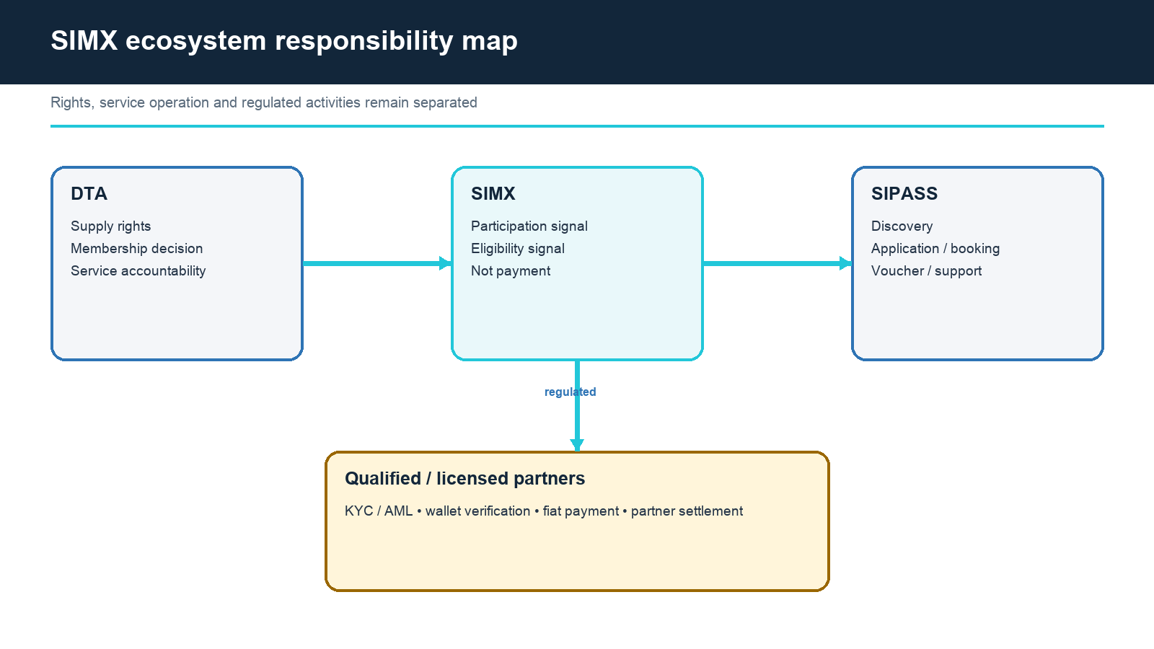
Figure 1. SIMX ecosystem responsibility map.

2.1 Accountability by layer
Layer | Primary responsibility | Evidence before a final claim
DTA | Membership acquisition through the SPV, programme policy, usage-fee formula, membership decision, usage-fee payment, SINODE operation, service accountability | Corporate approvals, membership contracts, policy and operating records
SPV (SIMX issuer) | Holds the membership portfolio, settles it into trust, issues SIMX, receives usage fees, makes distributions | Incorporation, trust deed, Portal agreement, distribution records
Trustee | Protects SIMX holder rights over the membership portfolio; approves changes to the usage-fee formula; participates in SINODE's signing structure | Trustee appointment, trust deed, approval records
SINODE | Allocation, settlement and record-keeping under published rules; no discretion, no legal personality | Deployed code hash, audit, invariant tests, event log
SIPASS.co | Public content, product discovery and service context | Stable URLs plus product-to-contract mapping
SIPASS.app | Application, booking, confirmation, voucher and support interface; source of usage facts | Release map, E2E tests and transaction evidence
SIMX | Participation in the membership portfolio and its usage income | Rights terms, trust deed, implementation, audit and disclosures
Membership Pass | Right to use the memberships at a published programme level | Rights terms, implementation, audit and disclosures
Qualified/licensed partners | KYC/AML, wallet verification, payment, settlement or regulated care | Licence/qualification, contract, RACI and audit trail

Responsibility cannot be outsourced by description alone. DTA must identify which legal entity performs each action, which party holds the relevant licence or qualification, which system retains the record, who responds to an incident, and what happens when a partner is suspended or replaced.
DTA stands on both sides of the central transaction: it sponsors the SPV that holds the memberships, and it pays the usage fee that becomes SIMX income. That is a related-party relationship and is treated as one. The usage-fee formula is fixed at issuance and published; a change requires the trustee's approval and public notice; and DTA cannot alter it alone. Chapter 8 sets out the controls.
CONTROL PRINCIPLE
The party performing a regulated or high-risk action must be named in contracts, system design, customer disclosures and the incident plan. The website, white paper, financial plan and live system must tell the same story. A smart contract is not a party; the party that operates it is.

CHAPTER 03

3. Industry Background
Thailand's value-over-volume direction creates a credible context for premium access, quality and wellness—without proving DTA's execution.
The Tourism Authority of Thailand's 2026 direction emphasises quality-led growth, premium positioning, wellness, digital platforms and stronger value per journey. The Bank of Thailand has also noted changing tourist spending patterns and greater attention to value and service quality. These official directions support the relevance of premiumisation; they do not establish DTA market share, customer demand or partner capacity.
High-end tourism is not simply a higher price. It depends on scarce or difficult access, transparent terms, service recovery, multilingual assistance, safety, supplier quality and consistent fulfilment. A premium membership proposition must therefore be designed as an operating system with evidence, not as a token-gated storefront.
Sector pressure | Premium response | DTA evidence requirement
Price and FX sensitivity | Increase service value, certainty and personalisation | Pricing method, customer research and measured conversion
Regional competition | Curated access and differentiated supplier rights | Executed contracts and renewal terms
Cautious spending | Clear inclusions, cancellation and service recovery | Terms, refunds and complaint records
Trust and safety | Qualified partners and accountable support | Licences, SLAs, audit and incident evidence

3.1 Golf first; healthcare later
Premium golf provides the initial operating category because club memberships are a defined, transferable asset: most Thai golf club memberships are transferable subject to the club's terms, corporate memberships exist, and a resale market exists. That makes a membership both an operating right and an asset whose acquisition cost, usage value and disposal value can be evidenced. DTA must distinguish a membership, a usage right, an allotment, an agency appointment, a wholesale arrangement and a referral agreement. Each creates different availability, accounting, consumer and liability consequences, and only memberships and comparable transferable rights are eligible for the portfolio held in trust.
Healthcare and wellness are a planned extension rather than a live benefit. The opportunity is strategically consistent with Thailand's wellness direction, but execution introduces licensed-provider, medical advertising, referral, clinical responsibility, informed-consent and sensitive-data requirements. Neither SIMX nor the Membership Pass nor DTA membership may determine clinical eligibility or replace a provider's medical judgement.
Service line | Current status | Minimum gate
Premium golf | EVIDENCE REQUIRED | Executed membership contracts, transferability terms, availability, settlement and service-use evidence
Premium tourism / concierge | DEVELOPMENT / EVIDENCE REQUIRED | Supplier responsibility, support model and E2E transaction records
Hotel memberships | EVIDENCE REQUIRED | Executed membership or comparable transferable rights and availability
Wellness | PLANNED | Licensed or qualified provider contracts and advertising review
Medical care | PLANNED | Licensed hospital/clinic, clinical responsibility, consent and health-data controls

NO CLINICAL CLAIM
DTA should describe future healthcare only as a membership or concierge pathway through licensed providers. It must not promise diagnosis, treatment outcomes, priority based on wealth, or access that conflicts with clinical and legal requirements.

CHAPTER 04

4. Market Opportunity
The opportunity is defined by service needs and eligibility, not by nationality or unverified token-holder statistics.
The intended users are eligible Thai and international members who value access, service certainty and coordinated premium experiences. Foreign residents who stay in Thailand for extended periods are a natural segment: they hold Thai bank accounts, use Thai services repeatedly, and are the demand a club membership is designed for. Thailand's Long-Term Resident visa alone recorded 10,773 approvals between September 2022 and July 2026, and privilege and retirement programmes add to that base. International digital-asset holders may also be a high-propensity segment because they may seek a reliable local pathway into premium Thai services. None of these are the only eligible users, and neither residency nor digital-asset ownership removes suitability, sanctions, source-of-funds or service-capacity constraints.
The investors in SIMX are a different population from the members who hold the Membership Pass. SIMX is offered to investors eligible under the Thai ICO route. The Membership Pass is held by members. The two may overlap in individuals but are distinct in role, and this paper does not assume that one becomes the other.
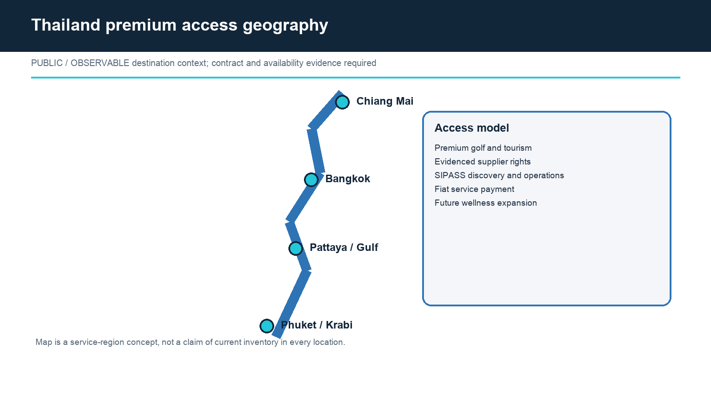
Figure 2. Thailand premium access geography and evidence boundary.

4.1 Customer and use-case segmentation
Segment | Need | Membership Pass relevance | Service boundary
Long-stay foreign residents | Repeat premium access, local coordination, a membership they can actually use | Primary member segment; programme levels sized to repeat use | Eligibility, capacity and club terms still apply
Thai premium travellers | Curated domestic access and community | May apply and participate under the same rights | Eligibility and supply still apply
International digital-asset holders | Local verification, multilingual coordination and premium access | Wallet-based eligibility signal may complement application | Not proof of credit or service entitlement
Corporate / hosted groups | Coordinated itineraries and accountable fulfilment | Corporate programme levels under the same rules | Corporate contracting and payment remain separate
Wellness / medical travellers | Trusted provider navigation and privacy | Future programme signal only | Licensed provider makes clinical decisions

DTA measures the opportunity through conversion and service evidence: verified applications, approval rates, contracted capacity, booking completion, fulfilment, cancellation, refund, repeat use, member satisfaction and supplier renewal. Token-holder counts, social reach or listed products alone do not establish the business case.
Market size is therefore not the measure of the opportunity. The published measure narrows from the Thai premium tourism market to the memberships the SPV holds, from those memberships to the member capacity their allocation and operating days support, and from that capacity to the usage members actually complete. Only the narrowed figure is published, and every step carries a dated evidence reference.

4.2 Competitive alternatives
Alternative | Strength | Gap addressed by DTA | Evidence needed
Premium cards | Global payment, established benefits and underwriting | Digital-asset-aware application and a membership portfolio members can actually use | Verification method and real member benefits
Private banking | Wealth advice and concierge | Portable membership and programme participation | Qualified partner boundary and service quality
OTA / travel marketplaces | Inventory breadth and price comparison | Held memberships and accountable concierge | Membership contracts and fulfilment records
Private clubs | Exclusivity and member network | Cross-club Thailand access from one pass | Membership policy and capacity
Web3 communities | Wallet-native engagement | Real-world service evidence and regulated separation | Security, partner and transaction proof

POSITIONING
SIMX competes on evidenced assets, evidenced usage income and regulated structure. The Membership Pass competes on transparent membership use, verified application and evidenced premium operations. Neither competes by promising price appreciation, an assured yield, automatic status or cheaper payment.

BASIS OF VALUE — TWO INSTRUMENTS
The value of the Membership Pass is measured by what approved members obtain from the memberships: the subscription-equivalent value of the programme level, the discount realised on usage, priority access, concierge support, and any hotel or additional rights under contract. The value of SIMX is measured by the net usage income the memberships generate and by their disposal value, both of which depend on members actually using them. Neither is measured by payment volume, by trading volume, or by the total size of the Thai tourism market. Two inputs are required for both and both are evidenced as of a stated date: member capacity, derived from the memberships held (the number of clubs, the allocation held at each, the operating days assumed and the annual usage assumed per member), and usage actually completed, derived from SIPASS booking, fulfilment and settlement records. Figures are separated between the current plan period and longer-term targets, and any component not supported by a held membership is excluded from the published value.

CHAPTER 05

5. Token Economy & Blockchain Design
Two tokens, one transaction, non-payment separation and transparent decision gates.
The design begins with legal and operational rights, not with a chain logo or token price. Each contract encodes only the behaviour consistent with the approved rights term sheet for that instrument. Personal identity, bookings, payments, partner settlement and future medical data remain outside the public ledgers.
CORE TOKEN RULE
Neither SIMX nor the Membership Pass is a means of payment. Service prices and partner settlement use fiat or appropriately licensed channels. Transfers of either token do not discharge a service obligation.

WHY NEITHER TOKEN CAN FUNCTION AS PAYMENT
Both tokens are unsuitable as a means of payment by construction, not only by policy. Supply is fixed at issuance and no further issuance is planned, so supply cannot expand to meet payment demand; rising payment demand would raise price rather than improve payment function. A price-variable asset also transfers exchange risk to the customer at the time of payment and to the venue at the time of settlement, which is not acceptable in a premium service relationship. Accordingly all service prices in SIPASS are denominated and settled in fiat currency, transferring SIMX or the Membership Pass does not discharge a service obligation, and partner settlement occurs in the contractual settlement currency through licensed channels. No token payment path exists in the system.

SIMX function | Proposed implementation | Status
Participation in the membership portfolio | Balances and transfer events; portfolio held in trust off-chain and evidenced on the public register | DEVELOPMENT
Distribution of net usage income | Variable amount per period under the published formula, computed by SINODE from settled usage, paid by the SPV; no fixed or assured amount | DECISION GATE
Distribution of net disposal proceeds | At the end of the project period or on disposal of a membership, under the trust deed | DECISION GATE
Project information and advisory view | Policy-referenced access plus auditable non-binding proposal events | DEVELOPMENT
Payment | Excluded | CONFIRMED
Principal or return guarantee, ownership of any venue or membership, corporate vote | Excluded | CONFIRMED

Membership Pass function | Proposed implementation | Status
Programme level qualification | Balance/holding rule read under a versioned eligibility policy | DECISION GATE
Member status reference | Revocable, time-limited credential reference without personal data, issued after DTA approval | CONCEPTUAL
Usage allocation | SINODE allocates membership usage to approved the Membership Pass holders under published rules | DEVELOPMENT
Distribution of any kind | Excluded | CONFIRMED
Payment | Excluded | CONFIRMED

5.1 Chain Selection
The production chain for each token is selected jointly by legal, Portal, custody, engineering and security stakeholders against the criteria in this section, and is published once implementation and audit evidence exists. A chain popular for retail trading may be unsuitable for issuer controls; a highly controlled environment may be unsuitable for global wallet and exchange infrastructure. The decision record explains the trade-off, and the two tokens need not share a chain.
Criterion | Question | Required evidence
Thai compatibility | Can issuer, Portal, custody and transfer obligations be implemented? | Written stakeholder assessment
Global infrastructure | Are mature wallets, custody, explorers and integrations available? | Integration proof and support commitments
Security | What are the consensus, bridge, client and ecosystem risks? | Threat review and incident history
Token controls | Can required whitelist, pause, policy and event controls be supported? | Prototype and audit scope
Finality / cost | Are settlement finality, availability and fees fit for expected use? | Measured test results, not advertised TPS
Migration | Can holders be protected if the chain or contract must change? | Approved migration and rollback design

DECISION GATE
Final chain, chain ID, token standard, explorer, testnet/mainnet status and contract addresses for SIMX, the Membership Pass and SINODE must be published only after implementation, audit and approval evidence exists.

5.2 Smart-Contract Modules
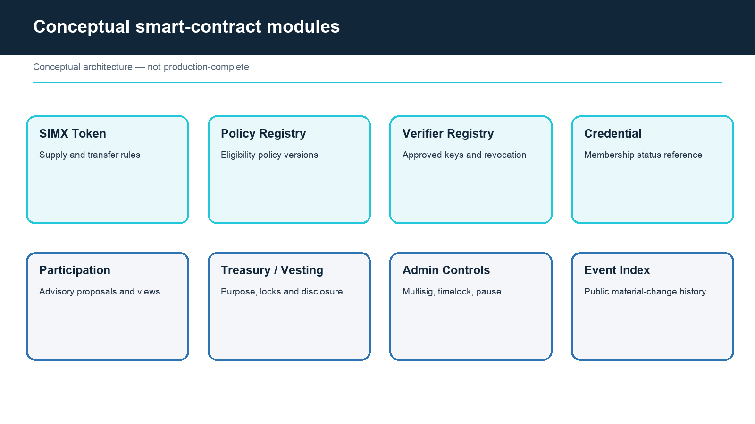
Figure 3. Conceptual SIMX smart-contract modules.
Modularity reduces the risk that a single upgrade silently changes every right. The SIMX token, the Membership Pass token, the SINODE allocation and settlement logic, the eligibility policy, the verifier registry, the membership credential, advisory participation, distribution accounting and administrative controls should have explicit interfaces, owners and events. Whether modules are separate contracts or one implementation is an engineering decision subject to audit.
Module | Minimum responsibility | Must not do
SIMX token | Balances, transfers, approved supply rules and events | Settle a SIPASS service obligation; pay a fixed return
Membership Pass token | Balances, transfers, approved supply rules and events | Receive or pay any distribution
SINODE — allocation | Allocate membership usage to approved the Membership Pass holders under the published rules | Exercise discretion; read personal data
SINODE — settlement | Compute usage fees under the published formula from settled usage; compute distributable net income | Change the formula without the trustee's signature
Policy registry | Versioned eligibility rules, programme levels and effective dates | Store identity or medical data
Verifier registry | Approved keys, scope, expiry and revocation | Make the final DTA membership decision
Credential | Non-sensitive membership status reference | Guarantee inventory or clinical access
Participation | Non-binding proposal/view events for SIMX holders | Replace corporate governance

5.3 Supply Governance and Allocation
Supply is sized rather than assumed, and the two tokens are sized differently.
SIMX supply is sized to the membership portfolio. The offer amount is derived from the approved acquisition budget for the memberships, the trust and issuance costs and the reserves set out in Chapter 8; the token price follows from the offer amount divided by the public sale volume; and the supply equals the volume issued. Supply is fixed at issuance and no further issuance is planned. Additional memberships acquired later are funded from retained income under the trust deed or from a separate, separately approved issuance, never by expanding SIMX supply without a new approval.
The Membership Pass supply is sized to evidenced demand: the published holding requirement for each programme level multiplied by the member capacity that the held memberships can serve. Each allocation tranche is justified by purpose and reviewed for conflict of interest, dilution and custody.
Parameter | Current position | Approval evidence
SIMX maximum supply | Equals the issued sale volume; fixed at issuance | Acquisition budget, Portal approval and contract cap
Membership Pass maximum supply | Holding requirement × evidenced member capacity | Membership register, capacity analysis and contract cap
Minting | Fixed cap for both; mint disabled after issuance | Role, multisig, timelock, event and emergency rules
Burning | No price-support promise | Legal and accounting purpose, public event and holder impact
Team / founder | Not fixed; vesting required in principle; no SIMX allocation without Portal approval | Conflict review, cliff, duration and controlled wallet
Treasury | Purpose-linked only | Budget, custody, reporting and related-party controls
Liquidity allocation | No commitment for either token | Separate legal, market-integrity and venue approval

TOKENOMICS BOUNDARY
The tokenomics must not include any guaranteed return, principal protection, issuer repayment promise, overseas-listing reward, market-purchase price support, guaranteed liquidity, or a valuation narrative unsupported by held memberships and evidenced usage. SIMX distributions are variable, are computed only from settled usage under the published formula, are disclosed in the offering terms, and are never presented as a fixed or assured yield. The Membership Pass carries no distribution.

5.4 Wallet Ownership Proof and Verification Attestation
A participant should prove wallet control by signing a domain-bound, time-limited challenge. The challenge must include the relying service, chain, wallet, nonce, issue time, expiry and policy version to reduce replay and phishing risk. DTA should not request a transfer merely to prove control.
A qualified or licensed verification partner may evaluate identity, sanctions and permitted wallet or digital-asset information. The partner should return the minimum attestation required by DTA: subject reference, result, scope, jurisdiction, policy version, issue/expiry time and revocation reference. Detailed personal and transaction data should remain in the responsible off-chain system.
Threat | Control
Signature replay | Single-use nonce, domain separation, short expiry and server-side consumption record
Wrong-chain or wrong-service signature | Explicit chain ID, contract/policy reference and relying-domain binding
Compromised verifier key | Scoped keys, rotation, revocation, monitoring and re-verification
Stale balance or eligibility | Block reference, timestamp, expiry and policy-version check
Excess data collection | Binary or tier-neutral result, retention limits and access logging

5.5 Membership Credential and Data Boundary
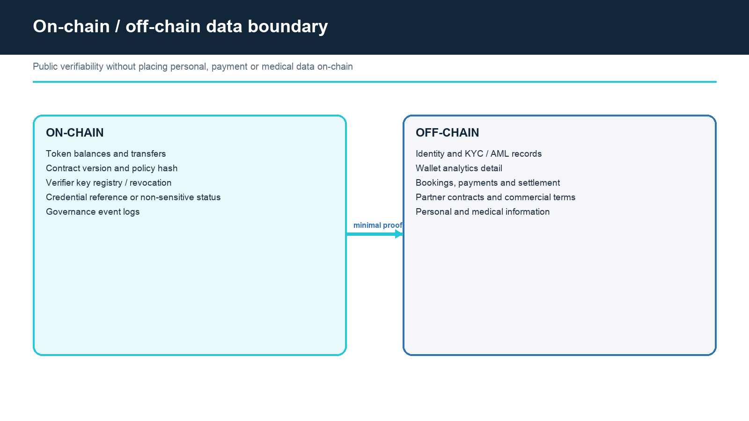
Figure 4. On-chain and off-chain data boundary.
A membership credential should be revocable and time-limited. It may reference an opaque subject identifier, programme, status, issue/expiry time and policy version. It should not contain a name, passport number, wallet analytics, booking history, payment detail, health status or provider record. The credential confirms a programme state, not a guaranteed service.
Usage facts follow the same rule. SINODE records that an allocation was made and that a usage fee was settled; it does not record who played where and when. The identifying detail stays in SIPASS.
Data class | Default location | Reason
Token balances and transfer events | On-chain | Public integrity and wallet interoperability
Policy/version, programme levels, usage-fee formula and verifier-key status | On-chain or publicly verifiable registry | Auditability and revocation
Allocation and settlement events; distributable income per period | On-chain, aggregated and pseudonymous | Holder verification of the distribution basis
Identity, KYC/AML and sanctions | Responsible partner off-chain | Privacy, correction and legal retention
Booking, fulfilment, payment, refund and settlement detail | SIPASS/payment systems off-chain | Operational detail, financial control and privacy
Membership contracts and trust records | Trustee and SPV records | Legal evidence and holder protection
Medical or wellness information | Licensed provider environment | Clinical confidentiality and sensitive-data law

5.6 Transfer and Jurisdiction Controls
Each token has one address and one set of essential rights that do not change by wallet location. The two tokens are two instruments, not two addresses for one right: SIMX carries participation and income, the Membership Pass carries use, and neither is convertible into the other. Jurisdictions may nevertheless require investor eligibility, transfer restrictions, marketing limits, permitted venues, holding periods or reporting. Those controls are implemented transparently through a versioned policy and disclosed before acquisition or transfer.
SIMX is offered in Thailand through the ICO Portal and may be traded only on venues permitted under the Thai route. The Membership Pass is issued outside Thailand and is not listed on a Thai digital-asset exchange. Any venue for the Membership Pass outside Thailand is subject to that jurisdiction's own securities and listing review, and no venue is assured.
If a chain migration is required for security, scalability or compliance, DTA uses a disclosed snapshot, eligibility rules, exchange/custody coordination, claims process, reconciliation and post-migration closure plan.
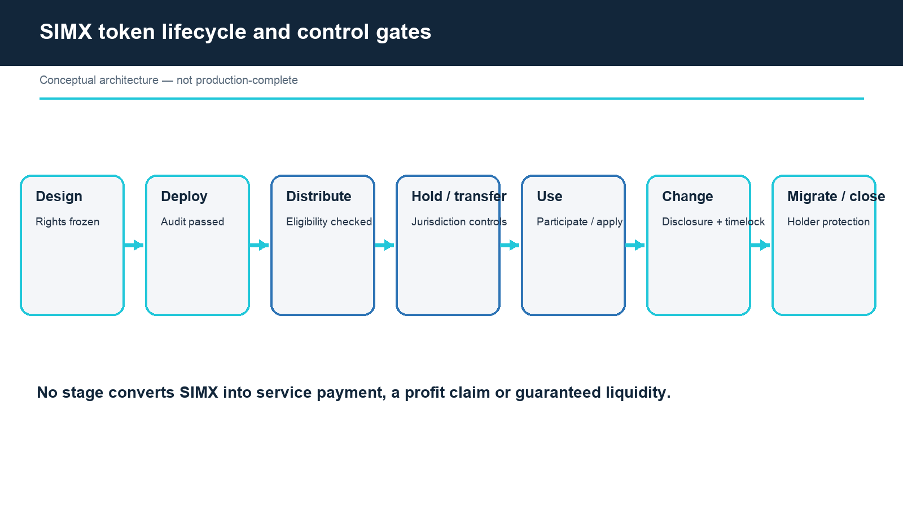
Figure 5. SIMX lifecycle and control gates.
Control | Design requirement
Whitelist / eligibility | Purpose, legal basis, policy version, operator and appeal route
Transfer restriction | Predictable rejection reason and no silent confiscation
Venue restriction | SIMX: permitted Thai route only. The Membership Pass: no Thai venue. No listing assurance for either
Sanctions / freeze | Narrow authority, documented process, review and disclosure
Migration | Objective cause, holder protection, audit trail and old-contract closure

5.7 Administrative Keys, Upgrades and Transparency
Administrative power is one of the largest technical and governance risks. No individual should unilaterally mint, upgrade, pause, seize, whitelist, migrate, change the usage-fee formula or move treasury tokens. Each role should have a defined purpose, threshold, independent signers, hardware-backed custody where appropriate, monitoring and an emergency succession process.
Power | Baseline control | Public event / disclosure
Mint or supply change | Disabled after issuance for both tokens | Amount, reason, authority and effective time
Usage-fee formula or allocation rule change | DTA proposal, trustee signature, timelock and advance notice | Old and new rule, reason, approval and effective time
Pause | Narrow emergency scope and independent approval | Incident reference, affected functions and review time
Upgrade | Audited implementation, timelock and rollback plan | Code hash, audit, rights impact and activation
Verifier management | Separate security/compliance approval | Key, scope, expiry, revocation and replacement
Treasury or distribution transfer | Purpose-linked multisig, budget check and trustee visibility | Destination category, amount and approval record

MATERIAL-RIGHTS PROTECTION
An upgrade must not add principal protection, mandatory repurchase, direct ownership of any property, facility or membership, payment functionality, or a distribution to the Membership Pass; must not make any SIMX distribution fixed or assured; and must not weaken a published holding requirement or an approved membership right to the detriment of existing members — through code, side agreements or marketing — without a new legal, regulatory and holder-protection process.

5.8 Audit and Incident Response
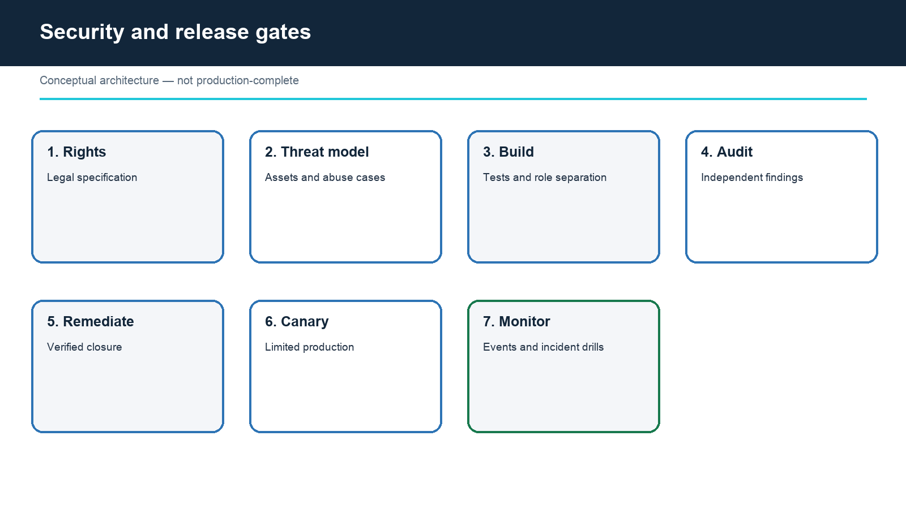
Figure 6. Security and production release gates.
Independent smart-contract review is required but not sufficient. The release scope should include contracts, front end, wallet signing, APIs, verifier integration, administration, treasury, distribution accounting, monitoring and incident procedures. Findings must be remediated and re-tested; an audit report with unresolved critical issues is not a release approval.
Incident phase | Required action
Detect | Monitor contract events, admin actions, verifier failures, anomalous transfers, settlement anomalies and application errors
Contain | Invoke only pre-authorised pause or access controls; preserve evidence
Assess | Identify affected rights, balances, distributions, personal data, services and jurisdictions
Communicate | Use approved holder, member, partner, trustee, Portal/regulator and public channels with factual updates
Recover | Apply audited fix or migration, reconcile state and verify service restoration
Learn | Publish post-incident findings where lawful and update controls, tests and disclosures

NO UNSUPPORTED PERFORMANCE CLAIM
TPS, SLA, gasless, multichain, wallet, automation and production-security claims require dated test or audit evidence. Without it, they are design targets.

5.9 SINODE — what is code and what is a person
SINODE is the smart contract, operated by DTA, that executes three functions: it allocates membership usage to approved the Membership Pass holders under the published allocation rules; it computes the usage fee owed by DTA and the distributable net income for each period under the published formula; and it keeps the record of both. It does these things without discretion. It holds no legal personality, is not a party to any contract, and cannot pay, promise or decide.
Layer | Who | Character
Policy — usage-fee formula, allocation rules, programme levels | DTA, with trustee approval for the formula | Decided by people and published in advance
Execution — allocation, settlement computation, record | SINODE | Rule-bound; no discretion
Accountability | DTA | Named in every contract, disclosure and incident plan

Automation here means the absence of discretion, not the absence of responsibility. Because the rules are published before they apply and the execution is recorded, DTA cannot adjust the usage fee or the allocation to its own advantage after the fact. A rule that could be changed silently would not be a rule; changes therefore follow the timelock, trustee-signature and notice procedure in Section 5.7.
SINODE's transparency has a boundary and it is stated plainly. SINODE verifies what happens inside it: that an allocation followed the rule, that a fee was computed from the inputs, that a record was written. It cannot verify what happens outside it: that a member actually played a round, whether a no-show occurred, whether a dispute is well founded. Those facts originate in SIPASS, DTA's operating system, whose booking, fulfilment and settlement records are the input to SINODE. The path from SIPASS record to SINODE input is documented, logged and auditable, and membership decisions remain DTA's under Chapter 6.

CHAPTER 06

6. Membership Structure
A three-layer model separates application, verification and approved use of the held memberships.
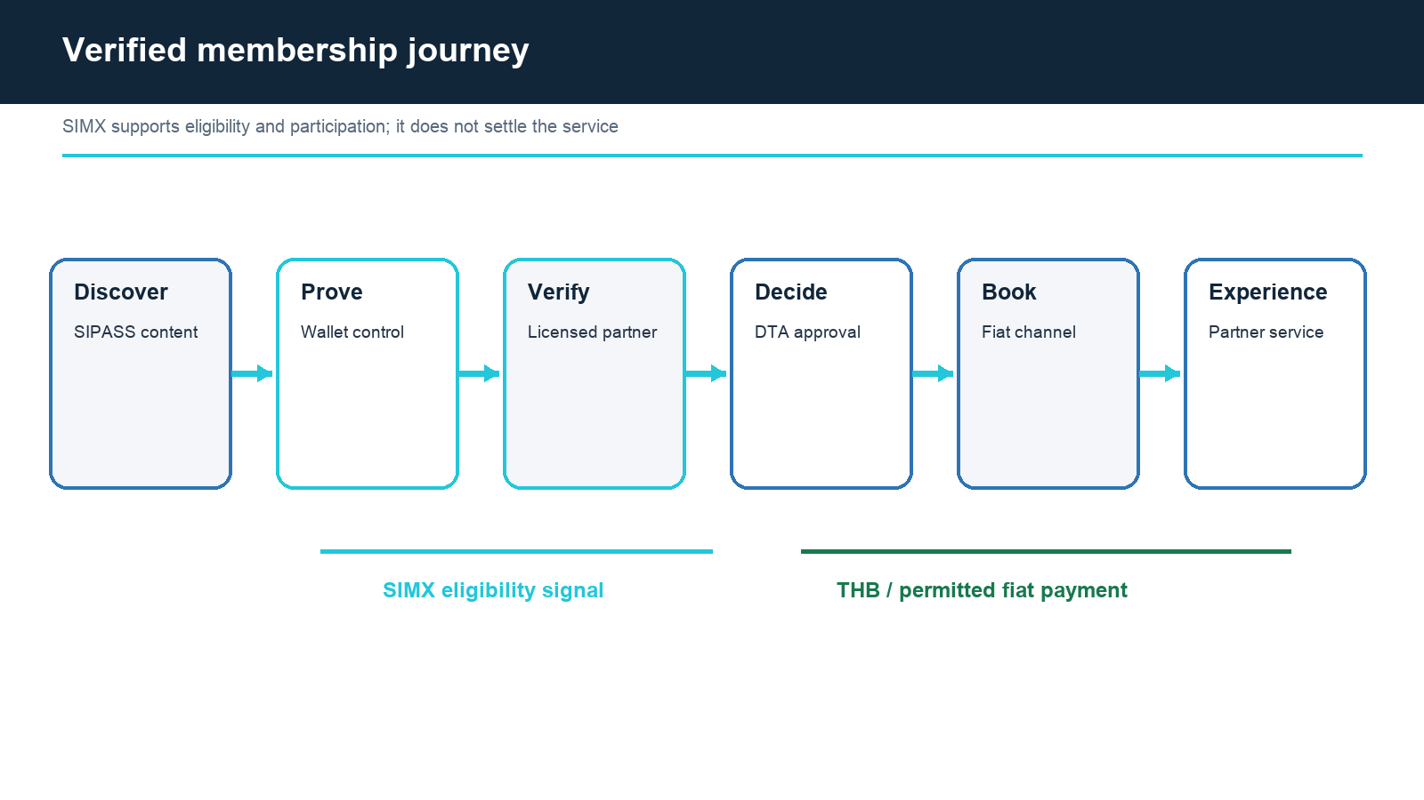
Figure 7. Verified membership and fiat service journey.
The membership system has three distinct layers: an application track, a verified member record, and programme-level access to the held memberships. A published the Membership Pass holding requirement supports the first layer as a qualification criterion. Verification and DTA approval are required for the second. The memberships the SPV holds, the club's own terms and fiat payment of the service price govern the third.
Membership exists before the Membership Pass does. DTA offers SIPASS memberships for a fiat subscription with benefits available now, on the same programme levels that a Membership Pass holding requirement will later map onto. A member approved before the holding requirement is introduced keeps that approval for the remainder of its stated validity period. No token is offered, promised or required in the membership programme until the holding requirement is published.
HOLDING REQUIREMENT
A programme level may be linked to a published the Membership Pass holding requirement. A holding requirement is a qualification criterion only: it does not by itself grant membership, a level, inventory or a booking. Every level requires held memberships, published criteria applied consistently, stated capacity limits, a stated validity period, a change procedure with advance notice that protects existing members, and clear non-guarantee terms. SIMX holding is not a membership criterion.

6.1 Approval, expiry and appeal
Stage | Decision | Owner | Control
Application | Complete / incomplete | DTA / SIPASS | Terms accepted, wallet challenge where applicable, and required fields
Verification | Pass / review / fail | Qualified partner | Identity, sanctions, permitted risk and policy evidence
Membership | Approve / restrict / reject | DTA | Human oversight, capacity, reason code and conflict handling
Validity | Active / expiring / suspended | DTA + partner inputs | Time limit, re-verification and material change
Appeal | Confirm / revise | Independent DTA reviewer | New evidence, audit record and response deadline

The policy explains balance measurement time, whether a holding period applies, how volatility affects a pending application, what happens after transfer, and how members receive notice of expiry or a programme change. No decision depends on hidden manual criteria or an unverifiable social claim.
A change to a published holding requirement or programme level follows a documented procedure: DTA publishes the proposed change with its reason and evidence, gives advance notice, and preserves the approved status of every existing member for the remainder of its stated validity period. A member whose status is affected may appeal under the process in this chapter. A raised holding requirement is not applied retroactively to an approved member during that period.
FAIR-TREATMENT BOUNDARY
Eligibility can be risk-based and capacity-aware, but DTA should document consistent criteria, accessibility, complaints, appeals and non-discrimination obligations under applicable law.

6.2 Benefits and the held memberships
Benefit type | Permitted description | Evidence required
Golf access | Use of a held club membership at the member's programme level when available | Membership contract, club terms, allocation and fulfilment records
Hotel access | Use of a held hotel membership or comparable right when available | Membership contract, availability and fulfilment records
Priority information | Earlier notice of a defined programme | Notice policy and delivery record
Priority application | Earlier or dedicated application window | Capacity, queue logic and equal terms
Concierge | Defined support channel and service scope | Staffing, SLA target and escalation record
Events / community | Participation under published rules | Event terms, capacity and conduct policy
Healthcare / wellness | Planned pathway through licensed providers | Provider, legal, privacy and clinical controls

Each programme has its own duration, price, inclusions, exclusions, cancellation, refund, liability and complaint terms. The Membership Pass does not replace those terms. A member may still be unable to use a membership because of capacity, the club's own rules, safety, provider judgement, legal restriction, force majeure or failure to pay the fiat service price.
Usage of a held membership generates the usage fee DTA pays to the SPV. A member's fiat service price and DTA's usage fee to the SPV are two different payments under two different contracts; the first is what the member pays for the service, the second is what DTA pays for the use of the asset. Neither is settled in tokens.
PARTNER EVIDENCE
A product image or SIPASS listing is useful public context but does not prove exclusivity, inventory, settlement rights or continuing availability. DTA maintains a membership-to-contract Evidence Register for every membership the SPV holds.

CHAPTER 07

7. Technology, Security & Holder Protection
Security is a system property spanning both tokens, SINODE, identity, membership, SIPASS, payment, trust and partner operations.
The technical architecture must preserve the business and legal separation described throughout this paper. The SIMX contract handles participation and distribution state. The the Membership Pass contract handles use-right state. SINODE handles allocation and settlement computation. The verification partner handles regulated checks. DTA handles membership decisions and policy. SIPASS handles service operations and is the source of usage facts. Licensed payment channels handle money. The trustee holds the memberships. Suppliers deliver the contracted service.
Trust boundary | Primary risk | Required evidence
Wallet ↔ application | Phishing, replay, wrong account or chain | Domain-bound challenge tests and security review
Verifier ↔ DTA | False result, stale key or excess data | Signed attestation spec, revocation and privacy assessment
DTA ↔ SIPASS | Inconsistent policy or unauthorised approval | Role controls, audit log and E2E tests
SIPASS ↔ SINODE | Wrong or manipulated usage input | Documented data path, signed inputs, reconciliation and audit
SINODE ↔ SPV / trustee | Wrong distribution basis or unapproved formula change | Invariant tests, trustee signature, period reconciliation
SIPASS ↔ payment | Duplicate charge, refund or reconciliation failure | Idempotency, ledger and settlement tests
DTA ↔ club / supplier | Unavailable or unfulfilled membership use | Membership contract, confirmation, voucher and service evidence

Figure 8. System trust boundary and data separation (technical view).

7.1 Smart-contract and key security
- Freeze the rights specification for each token before contract implementation and generate tests from the approved invariants.
- Use least-privilege roles, independent multisig signers including the trustee where the trust deed requires, hardware-backed custody where appropriate and documented succession.
- Apply a timelock to non-emergency changes, with public code hash, audit reference, impact analysis and activation time.
- Restrict pause and freeze powers to defined incidents; record reason, scope, approving parties and review deadline.
- Test upgrade, migration, replay, signature, integer, access-control, denial-of-service, settlement-computation and event-indexing scenarios.
- Commission an independent audit, remediate findings, obtain verification and retain the exact deployed build artefact.
Invariant | Expected test
Neither token can settle a SIPASS invoice | No contract or application route accepts a token transfer as service discharge
No fixed or assured return | No function pays an amount not computed from settled usage under the published formula
Membership Pass receives no distribution | No distribution path references the Membership Pass contract
Usage-fee formula cannot change unilaterally | Formula update requires the trustee's signature and the timelock
Supply cannot exceed the cap | Mint paths are disabled after issuance; upgrade paths preserve the cap
Credential contains no personal data | Schema and event tests reject prohibited fields
One signer cannot change material state | Role and threshold tests cover every administrative function

7.2 Application, API and privacy security
Holder protection depends on the interfaces most people use. The web and mobile experience should make the signing domain, requested permission and consequence visible; prevent unsafe approvals; apply session and device controls; and never ask users to disclose seed phrases or private keys.
Domain | Baseline control
Authentication | Phishing-resistant options, session expiry, device/risk signals and recovery controls
API | Authorisation by object/action, rate limits, schema validation, idempotency and tamper-evident logs
Secrets | No keys in source or client bundles; managed rotation and access audit
Privacy | Purpose limitation, minimisation, consent where required, retention and deletion/correction process
Third parties | Security and privacy due diligence, data-processing terms, incident notice and exit plan
Medical data | Provider-controlled environment and strict separation from token/public systems

RECOVERY BOUNDARY
Customer support may help a user recover an account under documented policy, but it cannot recover a non-custodial private key or promise restoration of token value after compromise.

7.3 Holder protection and evidence controls
Protection | Implementation principle | Disclosure
Material change | Legal review, audited code, timelock, trustee approval where required, and migration/rollback plan | Rights impact and effective date
Incident | Pre-defined severity, response owner and protected communication channels | Known facts, effect, action and next update
Conflict | Related-party approval, recusal, trustee oversight of the usage-fee formula and treasury purpose controls | Counterparty, value and rationale
Distribution basis | Period usage, fee computation, expenses, reserve and distributable amount published per period | Basis, amount and as-of date
Evidence register | Link public claim to membership contract, transaction, test, audit or approval | Status and as-of date
Complaints | Accessible intake, independent review and response timeline | Process and escalation route
Failure / closure | Continuity, data, contract, trust and token-state plan | Remaining memberships, disposal, claims and communication

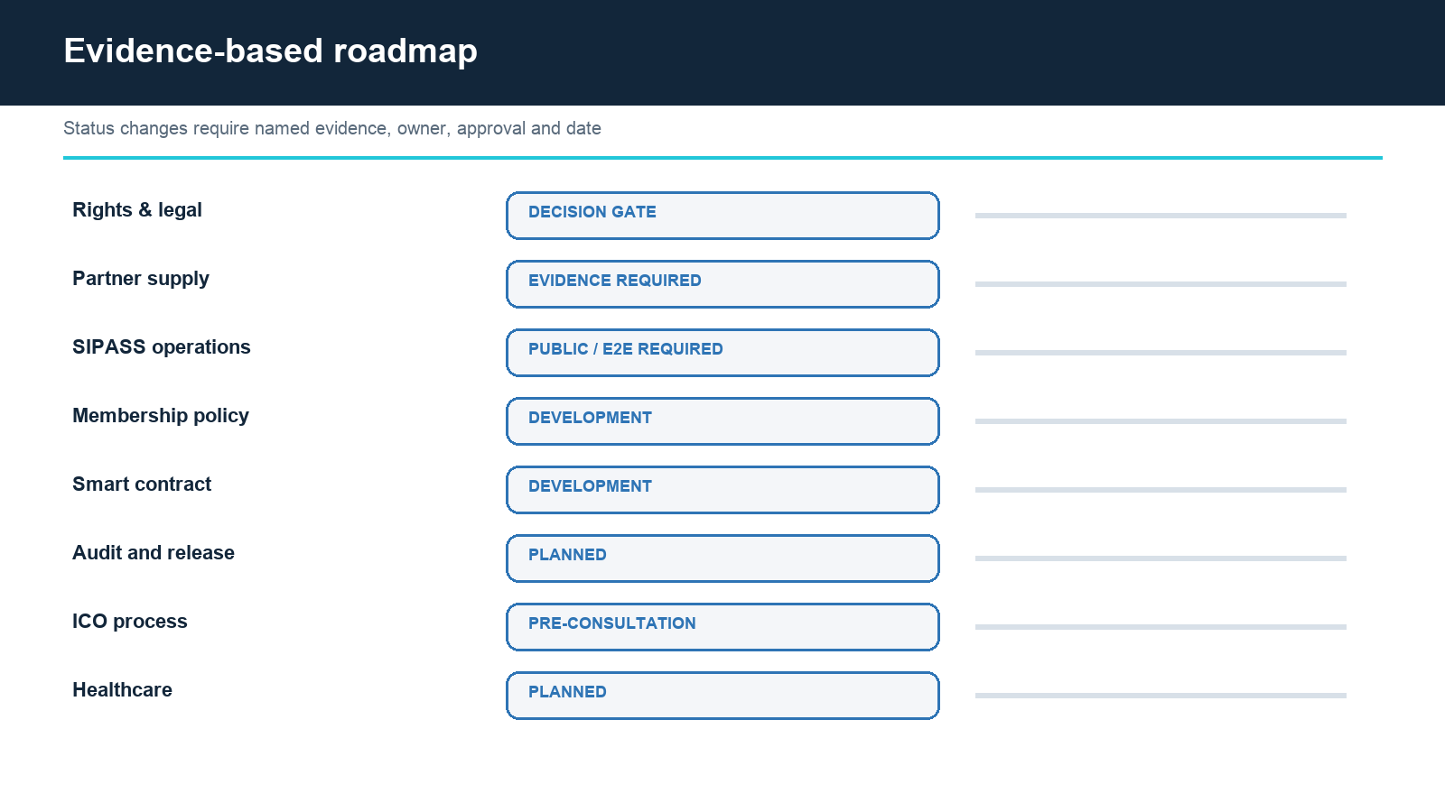
Figure 9. Evidence-based workstream and disclosure roadmap.
A final filing should include the scope and results of independent assurance, but must not imply that audit eliminates risk. Holder disclosures should remain usable after launch: concise rights summaries, contract addresses, administrative keys, policy versions, the usage-fee formula, per-period distribution bases, incidents and material changes should be published in a stable location.

CHAPTER 08

8. Fundraising & Treasury Structure
The offer funds a defined asset; its size, price and use follow the asset, not a valuation target.
The offer amount is derived bottom-up from the approved acquisition budget for the club memberships the SPV will hold, plus trust establishment, issuance, legal, Portal, compliance, security and audit costs, an operating reserve for the project period and the downside reserve set out below. The token price follows from the approved offer amount divided by the public sale volume, and is tested against the usage-income basis in Chapter 4 and the scenarios in Chapter 9.
Sale allocation, schedule and escrow structure are approved together with the offer amount and published in the offering terms. Each of these parameters is a decision gate: it is published once approved, and no figure is stated before approval.
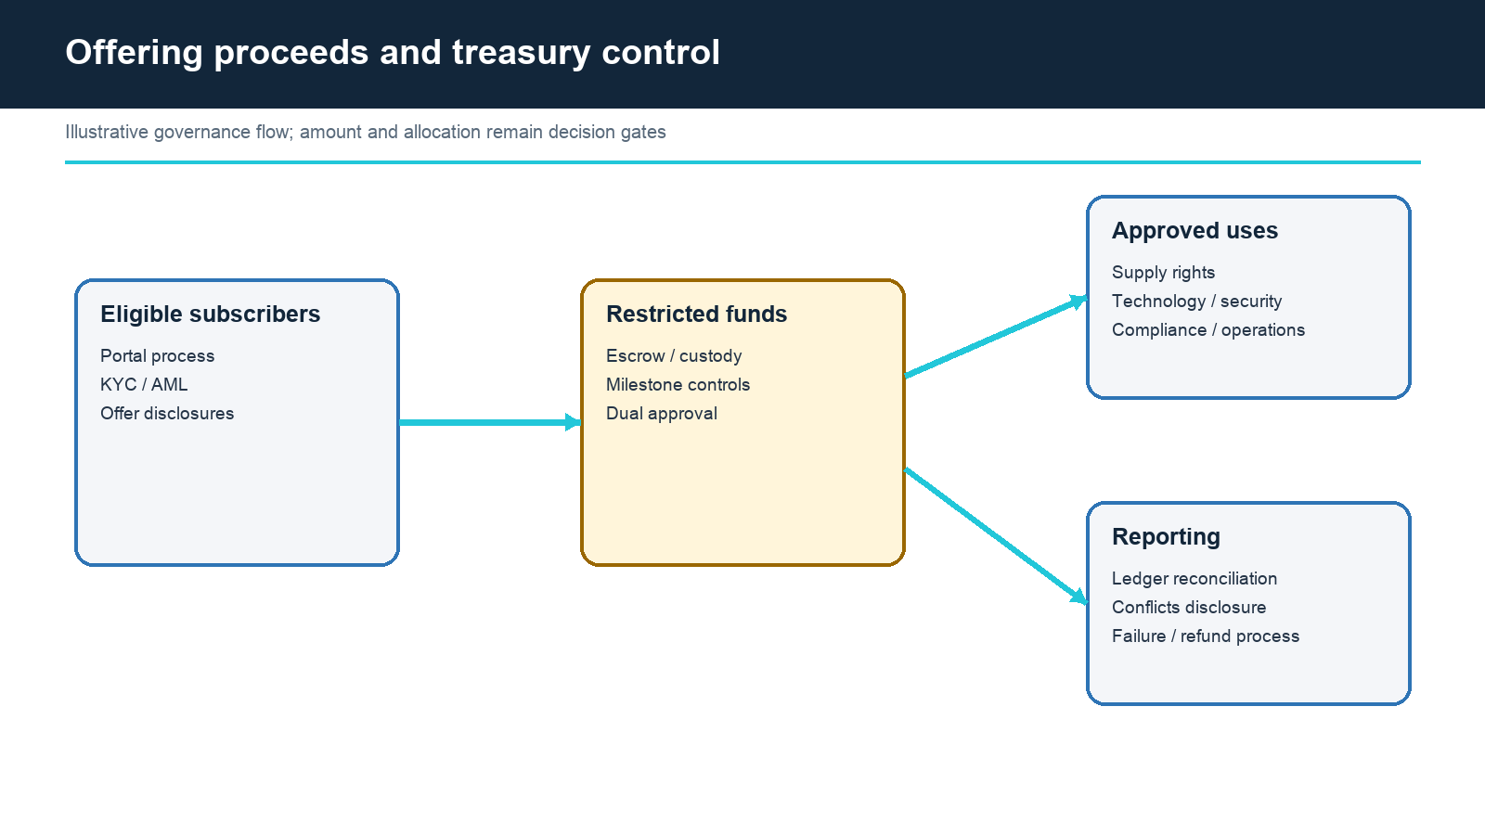
Figure 10. Conceptual proceeds and treasury control flow.

8.1 Structure: SPV, trust and trustee
The SPV is the issuer of SIMX. It acquires the memberships with the offer proceeds and settles them into a trust for the benefit of SIMX holders. A trustee is appointed under the trust deed to protect holder rights over the portfolio, to approve any change to the usage-fee formula, to participate in SINODE's signing structure for material changes, and to oversee disposal and the end-of-period distribution. The trustee is independent of DTA.
Party | Role in the structure | Control
SPV | Issuer; holds and settles the memberships; receives usage fees; makes distributions | Trust deed, Portal agreement, distribution records
Trustee | Holder protection; formula approval; signing participation; disposal oversight | Appointment, trust deed, approval and audit records
DTA | Sponsor; operator; payer of the usage fee; policy setter | Related-party controls in Section 8.3
Escrow agent | Holds subscription funds until the offering closes under its terms | Escrow agreement and release conditions

8.2 Use of proceeds and failure treatment
Purpose | Permitted scope | Release evidence
Club membership acquisition | Executed transferable golf and hotel memberships or comparable rights, settled into trust | Agreement, valuation, transferability terms, availability and trust settlement record
Trust, issuance and Portal | SPV, trust deed, trustee, Portal, filing, legal, KYC/AML, privacy, accounting and audit | Engagement, deliverable and approval
Technology / security | SIMX, the Membership Pass, SINODE, verification, monitoring and recovery | Acceptance, test, audit and remediation
Operations / concierge | Delivery, support, reconciliation and incident operation for the project period | Budget, staffing and control evidence
Reserve | Refund, incident, delay, membership renewal and legally required contingency | Segregated policy and authorised release

Before accepting funds, the SPV and DTA define minimum and maximum outcomes, subscription custody, milestone failure, refund eligibility, timing, fees, unclaimed amounts, remaining-funds treatment and the effect of project suspension. If the minimum is not reached, subscription funds are returned under the escrow terms and no membership is acquired. Restricted cash is separated from operating cash in both banking and accounting records.

8.3 Usage fee, related-party controls and distribution
DTA pays the SPV a usage fee for the memberships. The fee is computed by SINODE under a formula fixed at issuance and published in the offering terms. The formula references settled usage recorded in SIPASS and the fee basis for each membership; it does not reference DTA's discretion.
Because DTA sponsors the SPV and also pays the fee, the arrangement is a related-party transaction and is controlled as one:
Control | Requirement
Formula fixed at issuance | Published in the offering terms with the fee basis for each membership
Change procedure | DTA proposal, trustee approval, timelock, advance public notice; no unilateral change
Independent approval | Trustee approval of the formula and of any related-party transaction affecting the portfolio
Disclosure | Counterparty, basis, amount and rationale published per period
Audit | Period settlement reconciled by an independent reviewer before distribution

Distribution to SIMX holders is made by the SPV from net usage income for the period — usage fees received less the SPV's expenses and the reserve provided for in the trust deed — under the frequency and conditions set out in the offering terms. The amount varies with usage and may be zero in a period. Net proceeds from the disposal of memberships at the end of the project period, or earlier under the trust deed, are distributed after expenses. No amount is fixed, assured or guaranteed.
NOT AN OFFER
This White Paper is a design and evidence document. It is not a prospectus, a subscription invitation, or an assurance that an offering will proceed.

TREASURY BOUNDARY
Treasury and reserve transactions must not be marketed as price support, yield, guaranteed liquidity or an assured return to SIMX holders. Related-party transactions require trustee approval, independent review and disclosure.

CHAPTER 09

9. Financial Projections
Operating scenarios describe DTA's business. The distribution basis for SIMX is usage income under the published formula — not these scenarios.
FINANCIAL NOTICE
Illustrative, unaudited DTA operating scenario. Not a forecast of SIMX distributions and not an offer term. SIMX distributions depend on memberships held, usage completed and the published formula, and may be zero in a period.

Metric | Y1 | Y2 | Y3 | Y4
Users | 1,500 | 5,000 | 12,000 | 20,000
Golf bookings | 4,500 | 20,000 | 60,000 | 100,000
Golf GMV (THB) | 21.6M | 96.0M | 288.0M | 480.0M
Total operating revenue (THB) | 22.208M | 99.460M | 301.320M | 510.600M
EBITDA (THB) | (15.483M) | 22.519M | 103.701M | 194.752M
Net income (THB) | (15.983M) | 17.216M | 81.761M | 154.202M

These values are management scenarios rather than actual results. They require reconciliation to membership contracts, current SIPASS transactions, accounting records, cancellation/refund behaviour, taxes, payment fees, concierge cost, working capital and restricted cash. They describe DTA's operating business as a whole, not the usage income of the memberships the SPV holds.

9.1 Unit economics and accounting decision
Input | Scenario | Validation required
Weighted selling price | THB 4,800 | Product mix, contract price, taxes and observed bookings
Weighted B2B cost | THB 2,450 | Correct weighting and supplier invoices
Payment cost | 3% assumption | Provider contract, refund and cross-border cost
Contribution after payment cost | THB 2,206 | Cancellations, refunds, concierge and variable support
Revenue recognition | Not consistently defined | Principal-versus-agent accounting opinion by product

If DTA controls the service before transfer to the customer, gross recognition may be appropriate; if DTA arranges for another party to provide the service, only a commission or net margin may be revenue. The answer changes reported revenue, gross margin, tax and working capital and must be documented before filing. The usage fee DTA pays the SPV is an expense of DTA and income of the SPV, and is accounted for on that basis by each.
BASIS OF VALUE — SIMX
The value available to SIMX holders arises from the net usage income of the memberships held in trust and from their net disposal value. It does not arise from DTA's revenue, profit or cash flow, and holders have no claim on DTA's residual assets and no corporate voting right. Distributions are variable, are computed from settled usage under the published formula, and may be zero in a period. The two inputs are the memberships held and the usage completed; both are evidenced as of a stated date and published per period.

9.2 Usage-income scenarios
The distribution basis is modelled separately from the operating scenarios above. For each membership held, the model records the acquisition cost, the fee basis, the assumed operating days and annual usage per member, and the resulting usage fee; it then deducts SPV expenses and the reserve to arrive at distributable net income. Base, downside and severe-downside cases vary usage, renewal and disposal value. The model is published with the offering terms and is not presented in this paper before the memberships are contracted.
Scenario driver | Base | Downside | Severe downside
Usage completed vs capacity | Evidenced from SIPASS | Lower approvals and bookings | Material shortfall
Membership renewal | Renewed on contract terms | Partial non-renewal | Loss of a principal club
Disposal value | At or near acquisition cost | Below acquisition cost | Materially below
Distributable net income | Positive, variable | Reduced | Zero in one or more periods

9.3 Financial model standard and downside cases
Requirement | Standard
Period separation | Actual and Forecast periods are presented separately with as-of dates
Traceability | Each input links to a source document or system record
Recognition policy | One revenue and cost policy, consistent with the principal-versus-agent conclusion
Cash segregation | Restricted escrow and trust assets are separated from unrestricted operating cash
Distribution basis | Usage fee, expenses, reserve and distributable income modelled per period per membership
Completeness | Integrated monthly cash, balance sheet, tax and refund schedules
Scenarios | Base, downside and severe-downside cases, and a no-offering runway
Review | Independent review before filing

A revised model shows Actual and Forecast periods, sources, checks, base/downside/severe-downside cases, offer-failure runway and no-offering continuity. Downside drivers include lower approvals, slower membership acquisition, fewer bookings, lower net take rate, higher cancellations, non-renewal, FX movement, delayed healthcare and higher compliance/security costs.
GOING-CONCERN QUESTION
DTA should be able to show how the operating business continues for at least twelve months if the offering is delayed, reduced or does not occur, and how the trust and the memberships are protected if DTA cannot continue. This requires bank, capital, cost, revenue and trust-continuity evidence—not a token-sale assumption.

CHAPTER 10

10. Market Entry Strategy
Enter through evidenced Thai memberships and service execution, then expand only where rights and controls remain compatible.
Thailand is the operating foundation. The launch sequence prioritises a fiat membership programme with real benefits, a small number of held golf and hotel memberships, a complete membership decision process, working fiat payment and settlement, multilingual support, and verifiable fulfilment. Public catalogue breadth should not outrun held memberships or customer support.
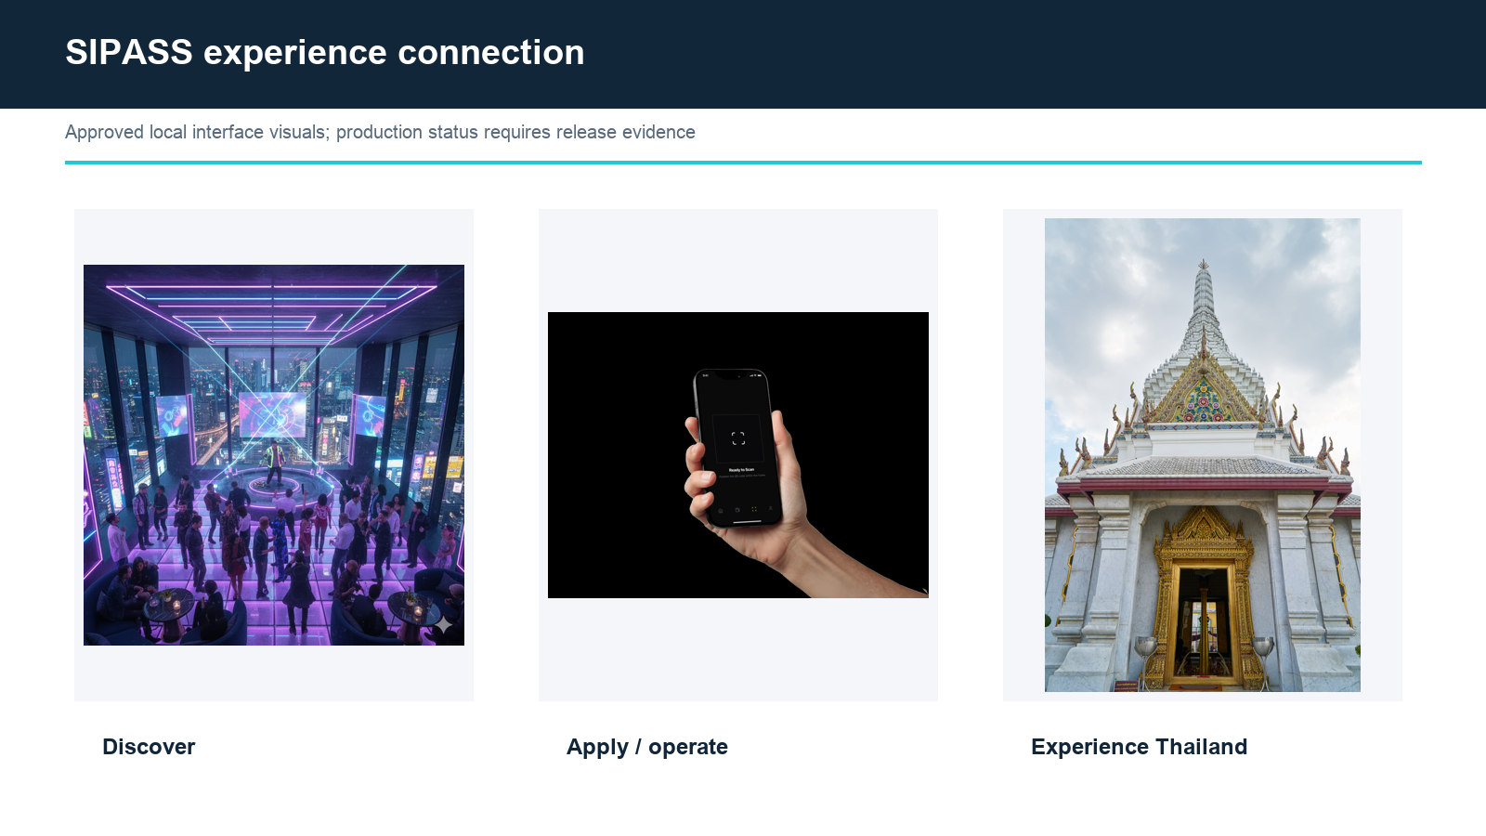
Figure 11. SIPASS discovery and operational experience connection.
Entry stage | Success evidence
Fiat membership programme | Verified applications, decisions, renewals, complaints and re-verification without any token
Membership acquisition | Executed transferable memberships, trust settlement and live availability
Service pilot | Booking-to-settlement evidence including cancellation and refund, on held memberships
Token pilot | Testnet contracts for SIMX, the Membership Pass and SINODE, audit, wallet proof, policy, settlement drill and incident drill
Regulated offer | Approved issuer/Portal route, trust deed, trustee, disclosure and proceeds controls

10.1 International and healthcare expansion
International expansion starts with member support and legal distribution analysis, not a list of promised exchanges. SIMX is offered in Thailand and is not offered, marketed or listed in Korea or elsewhere outside the Thai route. The Membership Pass may be considered for venues outside Thailand only after that jurisdiction's own securities and listing review; a Thai classification of SIMX does not determine the treatment of the Membership Pass anywhere. DTA submits the same rights terms, contracts and smart-contract behaviour for each target jurisdiction's legal and venue pre-review.
Workstream | Expansion gate
Thai and international member acquisition | Permitted marketing, language, sanctions, KYC/AML and suitability rules
Membership Pass venues outside Thailand | Substance-over-form securities opinion in the target jurisdiction and independent venue review
Other markets | Distribution, promotion, transfer, tax, privacy and consumer-law analysis
Premium healthcare | Licensed providers, clinical responsibility, advertising, referral and sensitive-data framework
Cross-border operations | Support hours, currency/payment partners, complaints, refunds and incident coordination

NO LISTING PROMISE
No Thai or foreign exchange name, date, liquidity, volume, market maker or listing outcome should be stated as confirmed for either token without the exchange's final decision and all applicable approvals.

CHAPTER 11

11. Roadmap
Evidence, owner and dependency determine status; target dates alone do not.
Figure 12. Evidence-based roadmap overview.
Status | Meaning
CONFIRMED | Approved internal principle supported by the identified authority
PUBLIC / OBSERVABLE | Visible public surface; underlying contract or operation may still need proof
EVIDENCE REQUIRED | Claim cannot be treated as complete until the referenced record exists
DEVELOPMENT | Designed or being implemented; not production-complete
PLANNED | Future expansion dependent on partners, budget, licences and law
DECISION GATE | Not fixed; requires named approval and evidence

11.1 Workstreams and next gates
Workstream | Current status | Next evidence gate
Rights / legal | DECISION GATE | Thai Portal/counsel written review of the two-instrument structure; target-jurisdiction review for the Membership Pass
Fiat membership programme | PUBLIC / EVIDENCE REQUIRED | Members, renewals and usage on the published levels, with no token
Membership acquisition | EVIDENCE REQUIRED | Executed transferable memberships, valuation and trust settlement
SPV, trust and trustee | DECISION GATE | Incorporation, trust deed, trustee appointment, escrow agreement
SIPASS operations | PUBLIC / EVIDENCE REQUIRED | Continuous E2E booking, refund and settlement evidence on held memberships
SINODE | DEVELOPMENT | Usage-fee formula, allocation rules, SIPASS data path, testnet, audit, settlement drill
SIMX contract | DEVELOPMENT | Chain decision, testnet, independent audit and remediation
Membership Pass contract | DEVELOPMENT | Chain decision, holding requirement, testnet, independent audit and remediation
Offering | PRE-CONSULTATION | Issuer, Portal, filing, escrow and budget approval
Healthcare | PLANNED | Licensed providers and dedicated legal/privacy controls
Foreign venues | NO COMMITMENT | Country review and independent venue decision

Each change of status records an evidence ID, accountable owner, reviewer, approval date, expiry or revalidation date and dependencies. Website, white paper, business plan, financial model, contracts and deployed code are released from the same approved claim register.
Two workstreams rank above the others. Acquiring transferable memberships is the first, because the portfolio, the usage income, the member capacity and the holding requirement are all derived from what is actually held. Evidencing usage is the second: the fiat membership programme runs before any token and generates the booking, fulfilment and settlement records that establish demand, so that the usage-fee formula, the offer amount, the token price and both supplies rest on completed usage rather than on assumption.

CHAPTER 12

12. Risk Assessment & Mitigation
SIMX and the Membership Pass can each lose all market value, distributions can be zero, and the business, membership or offering may fail.
Risk disclosure is not a substitute for control. DTA identifies the owner, indicator, threshold, response and evidence for each material risk. The following risks are not exhaustive and require expansion by qualified advisers for any final filing or offer.
Risk | Potential effect | Primary mitigation
Classification | Offer, transfer, marketing or venue may be restricted for either token | One rights term sheet per token and written jurisdictional review
Usage income variability | Distributions fall or are zero if members do not use the memberships | Fiat programme evidence before issuance; reserve; scenario disclosure; no assured amount
Membership asset | A club changes terms, refuses transfer, does not renew or closes; disposal value falls | Contract diligence, transferability terms, diversification across clubs, reserve, trustee oversight
Related-party fee setting | Usage fee set to DTA's advantage | Formula fixed at issuance, trustee approval of changes, independent review, disclosure
No offering / insufficient funds | No memberships acquired; runway and scope reduced | Minimum outcome and refund under escrow; no-offering plan; staged budget
No listing / liquidity | Transfer or sale may be difficult; value may fall to zero | No assurance; eligibility and venue review
Membership rejection | A Membership Pass holder cannot access intended programme | Clear criteria, expiry, reasons and appeal
Partner / supply | Unavailable, cancelled or poor service | Membership register, capacity, alternatives and refunds
Accounting / cash | Reported performance, distribution basis or runway may be wrong | Integrated model, per-period reconciliation and independent review

12.1 Technology, data and operating risks
Risk | Potential effect | Control focus
Smart-contract defect | Incorrect balance, transfer, supply, allocation, settlement or authority | Invariants, audit, remediation, pause and migration
Wrong usage input | SINODE computes fees or allocations from wrong SIPASS data | Documented data path, signed inputs, reconciliation, dispute process
Key compromise | Unauthorised change, formula change or treasury movement | Multisig with trustee participation, hardware custody, monitoring and succession
Wallet phishing | Holder loss or unsafe signature | Domain binding, clear UX, education and incident channel
Verification error | False approval/rejection or sanctions exposure | Qualified partner, policy, revocation and human review
SIPASS failure | Duplicate payment, lost booking, refund or settlement error | Idempotency, state controls, reconciliation and E2E tests
Privacy breach | Identity, wallet or later health-data harm | Minimisation, separation, access, encryption and incident response

Technology vendors and licensed partners introduce concentration and exit risk. DTA maintains service inventories, data maps, backup and recovery, substitution plans, contractual incident deadlines and tested methods for preserving membership, allocation and transaction evidence when a provider changes.
Four risks follow directly from the structure. If memberships are not acquired, or are lost on renewal, the portfolio and the usage income fall away, because the distribution basis is derived from what is held rather than from market size. If approved members fall short of the capacity assumed, usage income falls and distributions may be zero. A change to a published holding requirement may be contested by existing members, so the change procedure, notice period and protection of existing approved status are documented before any level is published. And because the Membership Pass may be held outside Thailand, its rights terms and promotion are reviewed in each target jurisdiction before any venue is considered.
RESIDUAL RISK
Independent audit, KYC/AML, escrow, a trustee or licensed partners reduce specific risks but do not guarantee security, compliance, business success, token value, distribution, service availability or approval.

12.2 Tourism, healthcare and governance risks
Risk | Potential effect | Mitigation direction
Tourism / FX / geopolitics | Demand, costs and source markets change | Diversified memberships and member markets, scenario planning and flexible capacity
Seasonality / weather / health event | Closures and cancellations reduce usage | Terms, alternatives, refunds, insurance, reserve and communication
Medical expansion | Licensing, clinical, advertising or data breach | Licensed providers, separate consent/data and limited DTA role
Advisory governance | Holder views conflict with corporate duties | Non-binding scope, clear authority and conflict policy
Treasury / trust conflict | Related-party benefit or misuse | Trustee approval, independent review, segregation, reporting and audit
Going concern | DTA cannot continue or fulfil programme | Capital/runway evidence, no-offering plan, trust continuity and orderly disposal

Participation rights may have limited practical influence. DTA retains legal and fiduciary decision responsibility; the board may reject a holder view where law, contract, safety, budget or service quality requires another course. The proposal process publishes scope, quorum if any, result and DTA response without implying shareholder governance.

CHAPTER 13

13. Legal & Regulatory Framework
Classification follows substance across rights, contracts, code and marketing—not the label selected by DTA.
Thai law and the approved ICO route determine whether and how SIMX may be offered in Thailand. The ICO Portal acts as a gatekeeper and is expected to examine issuer eligibility, the business plan, the underlying asset, token rights, allocation, technology and the accuracy and completeness of disclosures. Filing effectiveness or Portal acceptance would not guarantee business success, price, distribution, liquidity or foreign listing.
SIMX is offered as an Investment Token. The underlying asset is a portfolio of transferable golf and hotel club memberships acquired by the SPV and held in trust. What a holder receives is a variable share of the net usage income those memberships generate and a share of their net disposal proceeds — the same shape as an asset-backed investment token in which an SPV holds an income-producing asset in trust and distributes its income stream to holders. The income here is variable with usage rather than fixed by a lease, and this paper says so wherever the distribution is described.
The Membership Pass is a ready-to-use utility token issued outside Thailand. It confers the right to use the memberships at a published programme level and nothing else: no distribution, no participation in the portfolio, no claim of any kind. It is not offered in Thailand and is not listed on a Thai digital-asset exchange. Its treatment in any other jurisdiction is determined by that jurisdiction on the substance of its rights, and DTA seeks that determination before any venue is considered.
Classification follows substance across rights, contracts, code and marketing. The final determination on both instruments rests with the Thai SEC, the ICO Portal and applicable foreign regulators, and DTA conforms the rights terms to that determination. Until that determination is issued in writing, DTA does not describe either token as approved, as a regulated token, or as a security or non-security.
Jurisdiction / gate | Question
Thailand / ICO Portal | Is a portfolio of transferable club memberships held in trust an eligible underlying asset for an Investment Token, and is variable usage income an acceptable income stream?
Thailand / utility token | Does the Membership Pass, issued outside Thailand and not listed in Thailand, fall outside the Thai offering requirements, and what Thai-targeting limits apply to it?
Thailand / cross-border | What transfer, venue, marketing and Thai-targeting controls apply to SIMX?
Target jurisdictions for the Membership Pass | Does the substance of the Membership Pass across documents, code and promotion create a security or other regulated interest?
Other countries | What offer, promotion, exchange, tax, privacy and consumer restrictions apply?

13.1 Responsibility and compliance matrix
Activity | Proposed owner | Required evidence
Issuer and disclosures | SPV, sponsored by DTA | Authority, trust deed, Portal agreement, filing and change controls
Trust and holder protection | Trustee | Appointment, trust deed, approval and audit records
Membership acquisition and holding | SPV with DTA | Membership contracts, valuation, transferability, trust settlement
Usage-fee formula and allocation rules | DTA, trustee approval of the formula | Published formula, change records, per-period disclosure
Allocation, settlement computation and record | SINODE, operated by DTA | Code hash, audit, invariant tests, event log, SIPASS data path
Subscription KYC/AML | Portal and responsible licensed parties | RACI, screening, monitoring and retention
Membership wallet verification | Qualified/licensed specialist | Qualification, methodology, privacy and audit
Membership decision | DTA | Criteria, human review, log and appeal
Service payment | Licensed payment provider | Merchant agreement, security and reconciliation
Partner settlement | DTA plus licensed channel | Agreement, approval and ledger reconciliation
Medical care | Licensed medical provider | Licence, consent, clinical responsibility and data controls

PROHIBITED PRE-APPROVAL WORDING
Until the regulatory determination is issued in writing, do not state Thai SEC approved, regulated token, a confirmed classification, not a security/STO, or confirmed exchange listing as an established fact for either token. SIMX is described as offered as an Investment Token, and the Membership Pass as a utility token issued outside Thailand, and each description is always accompanied by the disclosure that the determination rests with the Thai SEC, the ICO Portal and applicable foreign regulators.

13.2 Pre-consultation questions
- Is a portfolio of transferable golf and hotel club memberships, acquired by an SPV and held in trust, an eligible underlying asset for an Investment Token under Thai law?
- Is a usage-fee income stream that varies with member usage, rather than a fixed lease, an acceptable basis for distribution, and what evidence of demand is required before offering?
- How should the related-party relationship — DTA as sponsor of the SPV and as payer of the usage fee — be controlled, and is trustee approval of a fixed, published fee formula sufficient?
- What trust, trustee, escrow, subscriber-eligibility and transfer controls apply to SIMX?
- Does the coexistence of the Membership Pass, a utility token issued outside Thailand and not listed in Thailand, affect the review of SIMX, and how should the contract linking the two instruments be disclosed?
- What audit, key-structure and source-code review requirements apply to SINODE as the allocation and settlement contract?
- Which website and pre-marketing statements are permitted before filing or effectiveness, and what may be said about the fiat membership programme?
- Does the removal of the retail investment limit for real-estate and infrastructure-backed offerings extend to a membership-backed offering?
- Which controls preserve one instrument per role where jurisdictions impose different distribution rules on the Membership Pass?
- What licences and privacy controls apply to wallet and digital-asset verification for membership?
- What additional licensing, advertising, consent and data restrictions apply before premium healthcare is included?
- Is the asset-backed investment token comparison an acceptable description of SIMX, given that the income is variable and no holder owns any membership, property or facility?
PARALLEL REVIEW
The structure is subject to Thai ICO Portal and jurisdiction-specific legal review. DTA submits the same rights term sheets, trust deed, architecture, usage-fee formula, financial boundaries and marketing text to the prospective Portal, Thai counsel and counsel in each target jurisdiction for the Membership Pass. Different descriptions create both legal and diligence risk.

CHAPTER 14

14. Conclusion & Next Gates
SIMX advances as an asset-backed, evidence-led investment token; The Membership Pass advances as the membership pass for the people who use the assets.
The project addresses a credible strategic problem: how to give eligible members a trusted, portable right to use a premium Thailand club network, and how to fund the memberships behind it under regulated, evidenced terms — while keeping regulated verification, service payment, partner settlement and future medical care in accountable channels. The answer is two instruments on two sides of one transaction: an investment token whose holders participate in memberships held in trust and receive their variable usage income, and a membership pass whose holders use them. Each is supported by held assets, completed usage, a published formula and deliberate separation — not by a promise of price, yield or automatic benefits.
Gate before a final White Paper or issuance | Required outcome
Rights and classification | Compatible written Thai Portal/counsel conclusions on SIMX and target-jurisdiction conclusions on the Membership Pass
Membership portfolio | Executed transferable memberships, valuation, transferability terms and trust settlement
Trust and trustee | Trust deed, trustee appointment, escrow agreement and usage-fee formula approved
Usage evidence | Fiat membership programme with completed SIPASS booking, fulfilment and settlement records on the held memberships
Membership | Approved criteria, partner, privacy, decision, expiry and appeal process; published holding requirement for the Membership Pass
Technology | Chain/standard decisions, SIMX, the Membership Pass and SINODE implementation, testnet, audit, remediation, settlement drill and incident drill
Finance and treasury | Integrated model with per-period distribution basis, no-offering runway, offer budget and restricted-cash controls
Disclosure | One approved claim register across website, white paper, business plan, trust deed, contracts and code

FINAL BOUNDARY
Neither SIMX nor the Membership Pass is a means of payment, and neither is used for partner settlement. SIMX confers participation in a portfolio of club memberships held in trust and a variable share of their net usage income and net disposal proceeds; it confers no right to use any membership. The Membership Pass confers, once membership is approved, the right to use the held memberships at the published programme level within their terms and available capacity; it confers no distribution of any kind. Neither token provides equity, debt, a corporate voting right, direct ownership of any property, facility or membership, a principal or return guarantee, mandatory repurchase, or exchange-listing assurance. Holding either token does not by itself grant membership approval, a level, inventory, a booking or a benefit.

Appendix A — Rights and technical disclosure register
A.1 SIMX
Right / feature | Position | Condition
Participation in the membership portfolio | Included | Memberships held in trust; no ownership of any membership, venue or facility
Distribution of net usage income | Included | Variable; computed from settled usage under the published formula; may be zero in a period; not a fixed or assured yield
Distribution of net disposal proceeds | Included | Under the trust deed at the end of the project period or on disposal
Project information | Included | Designated information; confidentiality and law apply
Advisory view | Included | Non-binding; not a corporate voting right
Use of any membership | Excluded | Use is carried by the Membership Pass; SIMX holding is not a membership criterion
Service payment | Excluded | Fiat or licensed channels only
Equity / debt / corporate vote | Excluded | No shareholder or creditor position in DTA or the SPV
Direct ownership of memberships or venues | Excluded | The SPV holds the memberships in trust
Principal or return guarantee | Excluded | No guarantee of any kind
Mandatory repurchase | Excluded | No buyback obligation
Price support / liquidity | Excluded | No assurance; treasury and reserve may not be marketed as support
Exchange listing | No assurance | Permitted Thai route only; independent legal and venue decisions
Chain / standard / address | Decision gate | Published after implementation and audit
Supply / allocation / vesting | Decision gate | Sized to the approved membership acquisition budget; fixed at issuance

A.2 Membership Pass
Right / feature | Position | Condition
Use of held memberships | Included | At the published programme level; verification, programme rules, capacity, club terms, DTA approval
Holding requirement / level | Included | Published criteria, capacity, validity period, change procedure protecting existing members
Priority notice / application | Included | No approval, inventory or service guarantee
Distribution of any kind | Excluded | No income, proceeds or return
Participation in the portfolio | Excluded | Participation is carried by SIMX
Service payment | Excluded | Fiat or licensed channels only
Equity / debt / corporate vote | Excluded | No shareholder or creditor position
Direct ownership of memberships or venues | Excluded | The SPV holds the memberships in trust
Principal or return guarantee | Excluded | No guarantee of any kind
Mandatory repurchase | Excluded | No buyback obligation
Price support / liquidity | Excluded | No assurance
Thai exchange listing | Excluded | Not offered or listed in Thailand
Other exchange listing | No assurance | Target-jurisdiction legal and venue decisions
Chain / standard / address | Decision gate | Published after implementation and audit
Supply / allocation / vesting | Decision gate | Holding requirement × evidenced member capacity; fixed at issuance

A.3 Contract roles
Contract role | Minimum control
Token admin (SIMX, the Membership Pass) | Independent multisig, bounded power, monitoring and succession
SINODE admin | Independent multisig including the trustee for formula and allocation-rule changes; no single-signer material change
Upgrade | Audit, timelock, public impact notice and rollback
Pause / freeze | Narrow emergency purpose, evidence, review and communication
Verifier keys | Scope, expiry, rotation, revocation and separate approval
Treasury / distribution | Purpose-linked budget, multisig, trustee visibility, conflict review and reporting

Appendix B — Evidence and financial validation
Evidence class | Examples | Disclosure use
Corporate | Registration, UBO, capital, board approval of DTA and the SPV | Issuer eligibility and accountability
Trust | Trust deed, trustee appointment, settlement records | Holder protection claims
Membership asset | Executed membership contracts, transferability terms, valuation, renewal and termination terms | Portfolio, capacity and disposal-value claims
Usage | SIPASS booking, fulfilment, cancellation, refund and settlement records per membership | Distribution basis and demand claims
Transaction | Payment, voucher, fulfilment, refund, settlement | Commercial operation evidence
Technology | Source, release, E2E test, audit, settlement drill | Feature and security claims
Financial | Bank, ledger, tax, accounts, budget, per-period distribution reconciliation | Actuals, runway, proceeds and distributions
Compliance | Portal/counsel, KYC/AML, privacy, licences | Classification and responsibility
Public claim | Website, white paper, plan and marketing version | Cross-document consistency

The financial model separates Actual and Forecast periods, links each input to its source, applies checks, applies one revenue and cost policy consistent with the principal-versus-agent conclusion, separates restricted escrow and trust assets from unrestricted operating cash, models the distribution basis per period per membership, and includes integrated monthly cash, balance sheet, tax and refund schedules together with base, downside and severe-downside cases. The operating scenarios in Chapter 9 are unaudited inputs until that model is completed and independently reviewed.
Held memberships are the primary evidence class. For each membership the Evidence Register records the club, the counterparty, the contract form and term, the transferability terms, the acquisition cost, the allocation held, the operating days assumed, the fee basis, the renewal and termination terms, the trust settlement record and an evidence ID, because member capacity, usage income, distribution and disposal value are all derived from those records.
FINANCIAL TABLE NOTICE
Illustrative, unaudited DTA operating scenario; not a forecast of SIMX distributions and not an offer term.

Appendix C — Official and project sources
Thai SEC — ICO Portal due-diligence role: https://www.sec.or.th/EN/Pages/News_Detail.aspx?SECID=8286
Thai SEC — Investment Token ICO amendments: https://www.sec.or.th/EN/Pages/News_Detail.aspx?SECID=10470
Thai SEC — foreign digital-asset platforms targeting Thailand: https://www.sec.or.th/EN/Pages/News_Detail.aspx?SECID=11698
Thai SEC — Strategic Plan 2026–2028: https://www.sec.or.th/EN/Documents/AboutSEC/strategicplan-2026-2028-en.pdf
Thai SEC — Emergency Decree on Digital Asset Businesses B.E. 2561 (unofficial translation): https://www.sec.or.th/EN/Documents/EnforcementIntroduction/digitalasset_decree_2561_EN.pdf
Thailand Board of Investment — Long-Term Resident visa programme: https://ltr.boi.go.th/
TAT — Thailand Tourism Next 2026: https://www.tatnews.org/2026/01/tat-sets-thailand-tourism-next-for-value-growth-plan/
TAT — Thailand Tourism Update at TTM+ 2026: https://www.tatnews.org/2026/06/thailand-tourism-update-at-ttm-2026-reinforces-quality-led-growth-direction/
Bank of Thailand — Monetary Policy Report 2025 Q2: https://www.bot.or.th/content/dam/bot/documents/en/our-roles/monetary-policy/mpc-publication/monetary-policy-report/MPR_2025_Q2.pdf
Market precedent (public disclosure) — SiriHub Investment Token, XSpring Digital ICO Portal: https://www.xspringdigital.com/en/sirihub
SIPASS public website: https://sipass.co
SIPASS application: https://sipass.app
Project sources reviewed: the approved SIMX rights direction and the supporting review records held in the Evidence Register.
DOCUMENT STATUS
English Master Version 1.0. Published for review by a Thai ICO Portal, the Thai SEC and qualified legal advisers. Not an offer, legal opinion, regulatory approval, exchange decision or assurance of business performance or distribution.

